BDC Recording using T-CODE SHDB
- Execute transaction SHDB to start the recording process.
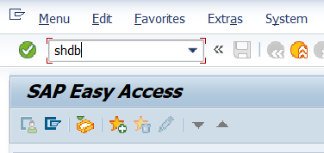

- Click on New Recording, provide a meaningful recording name and enter the target transaction code and Click on Start recording.

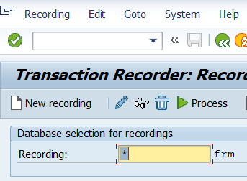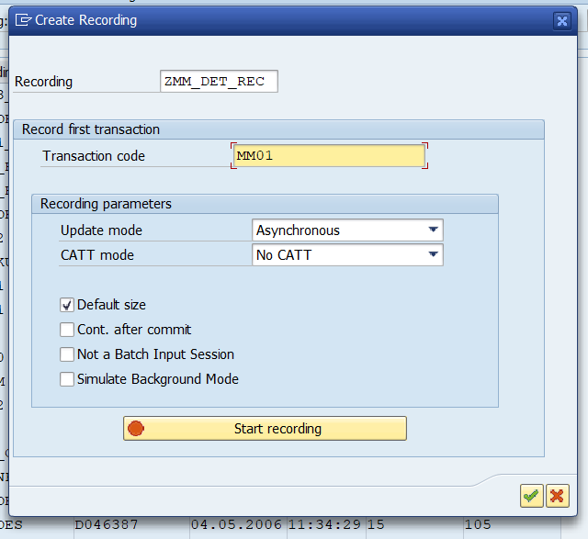

- Provide the all details for Creating a Material, then click ENTER. And Select views type and click ENTER.
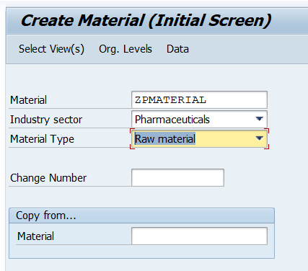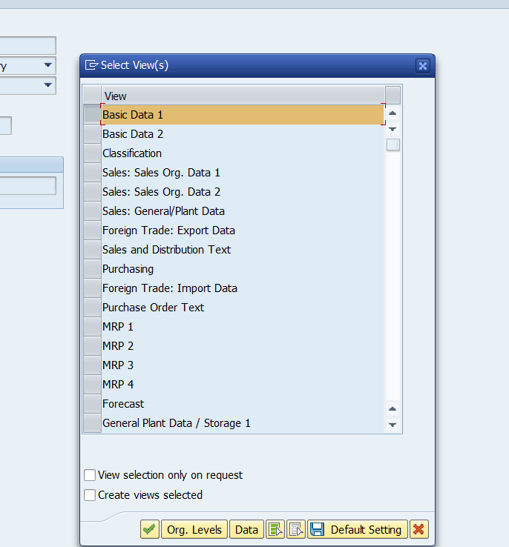
- Now provide the Description and General Data. Then click on Save Button and click Back button.

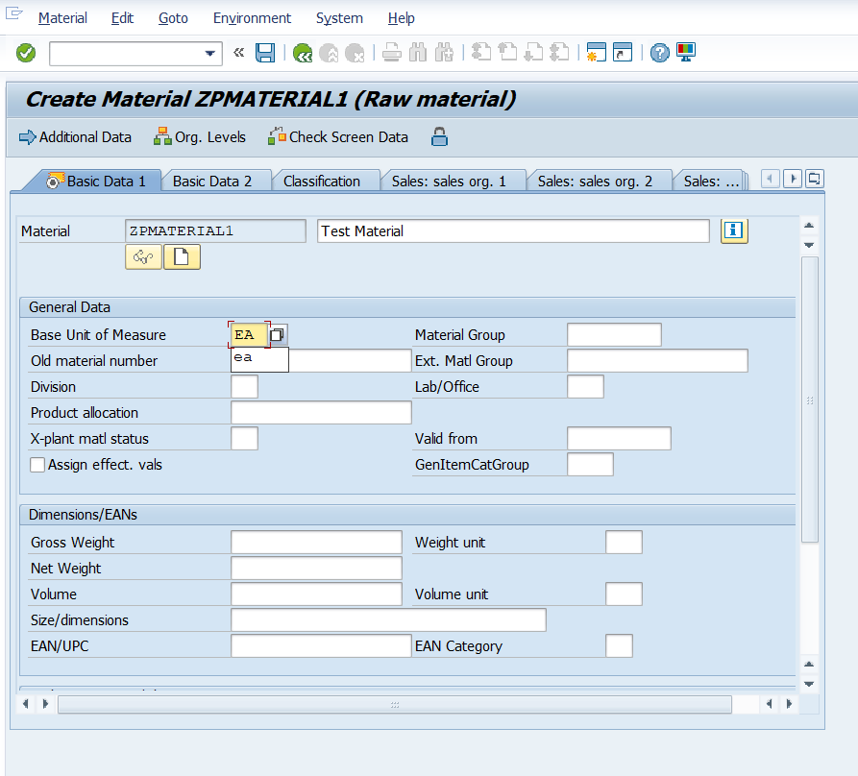

- Now save the recording and click on Bake button.
- Now Select our created recording and Click on Program Tab.

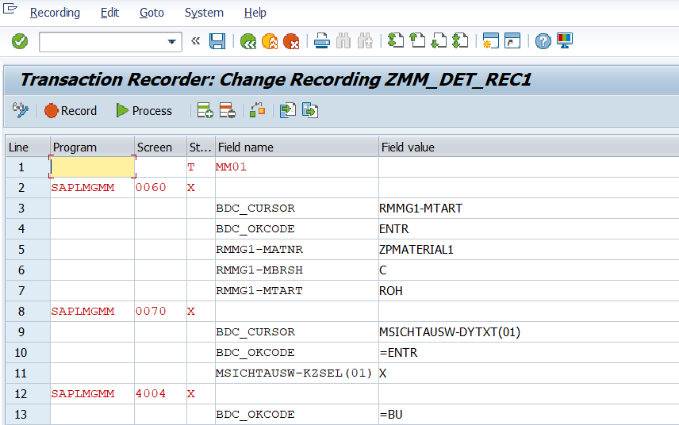

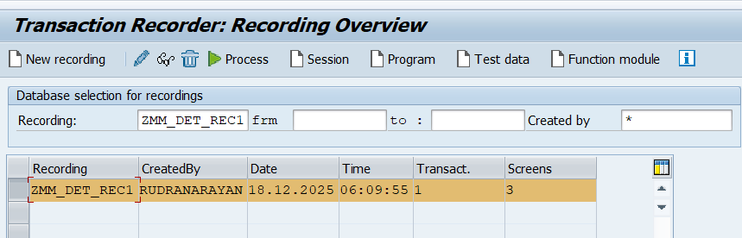

- Now provide the Program name and select the radio Transfer from recording and click on ENTER.
- Then provide the Title and Type ( Executable Program ) and click on Source code Button.

